Memory Game using LEDs
Description:
This is a Simon Says–style game where LEDs blink in a random sequence, and the player must replicate the sequence using buttons. The sequence gets longer with each round, testing the player’s memory.
Block Diagram:
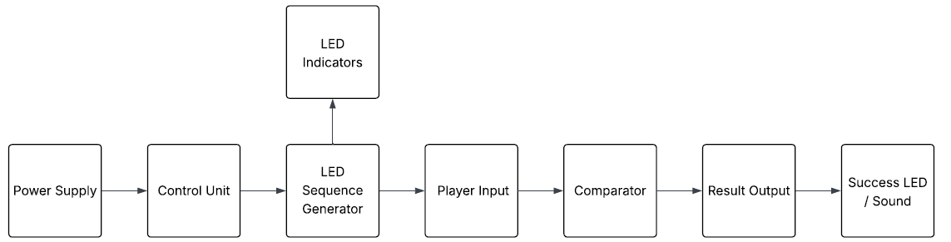
Pinout / Circuit Connection:
- LEDs → Digital Pins (3,5,10,13)
- Buttons → Digital Pins (2,6,9,11)
- Buzzer → Digital Pin (negative-4, positive-7)
Components Required:
- Arduino UNO
- 4 LEDs
- 4 Push buttons
- Buzzer
- Resistors
- Breadboard & jumper wires
Working Principle:
Arduino generates a random sequence of LED flashes. The player observes the sequence and tries to reproduce it using buttons. Arduino compares the input to the stored sequence. If correct, the game moves to the next level by adding a new step; if wrong, a buzzer or LED signals failure. The project illustrates how memory-based logic can be programmed into microcontrollers.
Operation (Step-by-Step):
- Connect LEDs and buttons to Arduino.
- Upload memory game code.
- Observe LED sequence.
- Repeat sequence using buttons.
- Continue to next level if correct.
Code:
// ----- PIN SETUP -----
int ledPins[4] = {3, 5, 10, 13}; // LEDs
int btnPins[4] = {2, 6, 9, 12}; // Switches
int buzzerNeg = 4;
int buzzerPos = 7;

int sequence[50]; // max sequence length
int level = 1;

void setup() {
Serial.begin(9600);

// LED and button setup
for (int i = 0; i < 4; i++) {
pinMode(ledPins[i], OUTPUT);
pinMode(btnPins[i], INPUT_PULLUP); // use internal pull-up
}

pinMode(buzzerNeg, OUTPUT);
pinMode(buzzerPos, OUTPUT);

randomSeed(analogRead(A0)); // random generation
}

void loop() {
generateSequence();
playSequence();
if (!playerInput()) {
gameOver();
} else {
level++;
delay(800);
}
}

// -------------------------------------------------------------

void generateSequence() {
// Add new random LED only when starting level
if (level == 1) {
for (int i = 0; i < 50; i++) {
sequence[i] = random(0, 4);
}
}
}

// -------------------------------------------------------------

void playSequence() {
for (int i = 0; i < level; i++) {
int led = sequence[i];
digitalWrite(ledPins[led], HIGH);
delay(400);
digitalWrite(ledPins[led], LOW);
delay(200);
}
}

// -------------------------------------------------------------

bool playerInput() {
for (int i = 0; i < level; i++) {
int correctBtn = sequence[i];
int pressed = waitForButton();

if (pressed != correctBtn) {
return false; // wrong button
}

// flash LED to confirm
digitalWrite(ledPins[pressed], HIGH);
delay(200);
digitalWrite(ledPins[pressed], LOW);
}
return true;
}

// -------------------------------------------------------------

int waitForButton() {
while (true) {
for (int i = 0; i < 4; i++) {
if (digitalRead(btnPins[i]) == LOW) { // pressed
delay(200); // debounce
return i;
}
}
}
}

// -------------------------------------------------------------

void gameOver() {
// buzzer sound
tone(buzzerPos, 300);
delay(600);
noTone(buzzerPos);

// flash all LEDs
for (int i = 0; i < 4; i++) {
digitalWrite(ledPins[i], HIGH);
}
delay(600);
for (int i = 0; i < 4; i++) {
digitalWrite(ledPins[i], LOW);
}

level = 1; // restart game
delay(800);
}
Conclusion:
The memory game helps students understand the interaction between random number generation, storage of sequences, and player input validation. It is a creative way to demonstrate arrays, loops, and game logic in Arduino programming.
References:
[1] Arduino.cc, “Random() – Arduino Reference,” 2023. [Online]. Available: https://www.arduino.cc/reference/en/language/functions/random-numbers/random/. [Accessed: Sep. 13, 2025].
[2] S. Monk, “Programming Arduino: Getting Started with Sketches,” 2nd ed., McGraw Hill, 2016.

